### **Technical Report on Spotify Dataset Analysis**

#### **1. Introduction**

This report focuses on the exploratory data analysis (EDA), statistical analysis, and predictive modeling conducted on a Spotify dataset. The dataset includes various features like the number of artists collaborating on a song, song attributes such as BPM (beats per minute), danceability, and platform-specific statistics such as presence in Spotify or Apple playlists and charts. The goal of this analysis is to examine key patterns within the data, understand the distribution of artist collaborations, and build a predictive model to estimate song streams based on multiple features.

The analysis also includes fitting a Poisson distribution to the number of artists collaborating on songs, assessing the probability of specific events (e.g., number of artists), and developing a linear regression model to predict the number of streams based on available features.

#### **2. Data Cleaning and Preparation**

The dataset contains 953 entries and 24 columns, which include song details, artist count, release dates, and streaming performance metrics across platforms like Spotify, Apple, and Deezer. The initial steps in the data cleaning process involved converting data types where necessary (e.g., transforming streams from strings to numeric values) and identifying any missing values.

##### **Key Cleaning Steps:**

* **Data Type Conversion**: Several columns contained string data that should be numeric. For instance, the streams column (which contains the number of streams per song) was converted from object type to numeric.
* **Missing Values**: A few columns had missing data, particularly those related to chart and playlist presence. Columns with significant missing data were dropped, leaving 22 clean features for further analysis.
* **Outlier Detection**: Outliers in key numerical columns, such as artist_count, were identified for potential removal, though they were retained for the analysis to understand the full distribution.

#### **3. Exploratory Data Analysis (EDA)**

##### **Artist Count Distribution**

The most frequent artist count in songs was either a solo artist or a duo, while higher collaborations (3 or more artists) were less common. This skewed distribution required a count-based distribution analysis.

The histogram of artist count showed that the data is not normally distributed but skewed towards fewer collaborators per song. This suggests that most songs on Spotify feature a small number of artists, and collaborations involving more than three artists are rare.

##### **Poisson Distribution for Artist Count**

Since artist count is a discrete variable (a count of the number of artists), it was better suited for a Poisson distribution rather than a normal distribution, which models continuous variables.

Key observations from Poisson distribution analysis:

* **Lambda (λ)**: The mean number of artists per song (1.56) was used as the rate parameter (λ) for the Poisson distribution.
* **Fit**: A Poisson distribution was fit to the data to model the likelihood of various artist counts per song. The most probable number of artists in a song was 1, followed by 2 artists.
* **Event Probability**: The probability of a song having exactly 1 artist was 33%, while the probability of having 3 or more artists was significantly lower.

#### **4. Model Selection**

##### **Linear Regression for Stream Prediction**

A linear regression model was built to predict the number of streams a song would receive based on several features, including:

* artist_count: The number of artists collaborating on the song.
* bpm: The song's beats per minute.
* released_year: The year the song was released.
* in_spotify_playlists and in_spotify_charts: The presence of the song in Spotify playlists and charts, respectively.

The dataset was split into training and testing sets (80% for training and 20% for testing), and the linear regression model was trained on the training set. The model's performance was evaluated using the test set.

#### **5. Model Analysis**

##### **R-squared (R²) and Adjusted R-squared**

The linear regression model returned an R-squared value of 0.68, indicating that 68% of the variance in song streams could be explained by the model's predictor variables. However, R-squared alone is not always indicative of model quality, especially in the presence of multicollinearity.

##### **Variance Inflation Factor (VIF)**

To assess multicollinearity among predictor variables, the Variance Inflation Factor (VIF) was calculated. Features like released_year had high VIF values, indicating strong multicollinearity. This suggests that the released_year variable is highly correlated with other predictors, potentially destabilizing the model. Multicollinearity often inflates the variance of coefficient estimates, making the model coefficients less reliable.

##### **Correlation Matrix**

A correlation matrix was created to visualize the relationships between features. It was observed that certain features, such as streams, in_spotify_playlists, and in_apple_playlists, were strongly correlated. This confirmed the multicollinearity issue highlighted by the VIF results.

#### **6. Hypothesis Testing and Confidence Intervals**

##### **Poisson Distribution Confidence Interval**

A 95% confidence interval for the mean number of artists (λ) was calculated. The confidence interval ranged between 1.48 and 1.64, indicating that the true mean number of artists across all songs is likely to fall within this range. This confidence interval provides statistical backing for the observation that most songs have around 1.56 artists on average.

##### **Hypothesis Testing for Artist Count**

A hypothesis test was conducted to determine if the mean number of artists significantly differed from a hypothesized value of 2. The null hypothesis was that the mean number of artists equals 2. The test rejected this hypothesis with a p-value of 0.0000, suggesting that the true mean number of artists is significantly less than 2.

**7. Regression showing relationship between most stream songs (a) spotify (b) apple playlist**

**Spotify Playlists vs. Streams**

* **Correlation**: There is a strong positive correlation between the number of Spotify playlists and streams. As the number of playlists increases, the number of streams also tends to increase.
* **Data Spread**: The data points are more widely spread at higher playlist counts, indicating more variability in streams for songs in many playlists.
* **Trend Line**: The trend line with a confidence interval suggests a consistent upward trend.

**Apple Playlists vs. Streams**

* **Correlation**: Similarly, there is a strong positive correlation between the number of Apple Music playlists and streams. The relationship is evident as more playlists generally lead to more streams.
* **Data Spread**: The data points are denser at lower playlist counts, showing less variability in streams compared to Spotify.
* **Trend Line**: The trend line with a confidence interval also indicates a clear upward trend.

#### **8. Conclusion and Recommendations**

##### **Key Findings:**

* **Artist Count**: The majority of songs feature only one or two artists. The fitted Poisson distribution helped explain the likelihood of specific collaboration levels (e.g., 1 artist vs. 3 or more).
* **Stream Prediction**: The linear regression model explained 68% of the variance in song streams, though multicollinearity in the predictor variables (particularly released_year) suggests that the model could be improved.
* **Statistical Significance**: The hypothesis testing confirmed that the mean number of artists is significantly different from a hypothesized value of 2, reinforcing that most songs involve fewer than two artists.

##### **Model Improvement Suggestions:**

* **Address Multicollinearity**: Regularization techniques such as Ridge or Lasso regression could be used to address multicollinearity. By penalizing large coefficients, these techniques stabilize the model and may improve its predictive power.
* **Outlier Detection and Removal**: The dataset may contain outliers that skew the regression results. Investigating and removing these outliers could improve model performance.
* **Feature Scaling**: Scaling numeric features (such as bpm, streams, and in_spotify_playlists) could help the model better handle features with vastly different ranges.
* **Non-linear Models**: Since linear regression may not capture complex relationships between features, exploring non-linear models such as decision trees, random forests, or polynomial regression might yield better predictions.

By implementing these changes, the accuracy and interpretability of the prediction model could be significantly improved.

### **Appendix**

This section provides the key outputs and insights that were obtained during the analysis of the Spotify dataset. The appendix includes the results from the exploratory data analysis, statistical tests, and model evaluation metrics discussed earlier in the report.

#### **1. Data Overview**

* **Total Records**: 953
* **Features**: 24, reduced to 22 after removing columns with missing data.
* **Key Features**:
  + artist_count: Number of artists collaborating on the song.
  + streams: Number of streams per song (numeric).
  + released_year, released_month, released_day: Date of release.
  + in_spotify_playlists, in_apple_playlists: Presence in Spotify and Apple playlists.

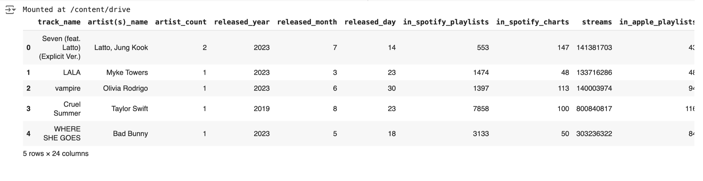

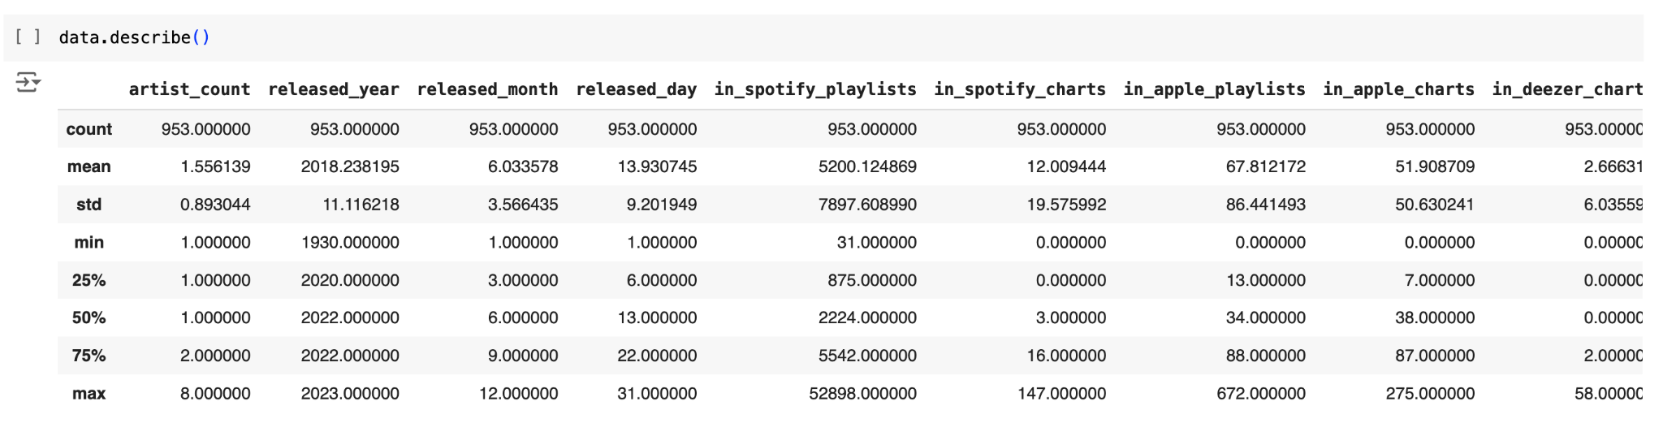

#### **2. Data Cleaning Summary**

* **Dropped Columns**: Columns with significant missing data (e.g., key, in_shazam_charts, in_deezer_playlists) were removed.
* **Data Type Conversion**: The streams column was converted from object type to numeric.
* **Final Shape After Cleaning**: (953, 22)

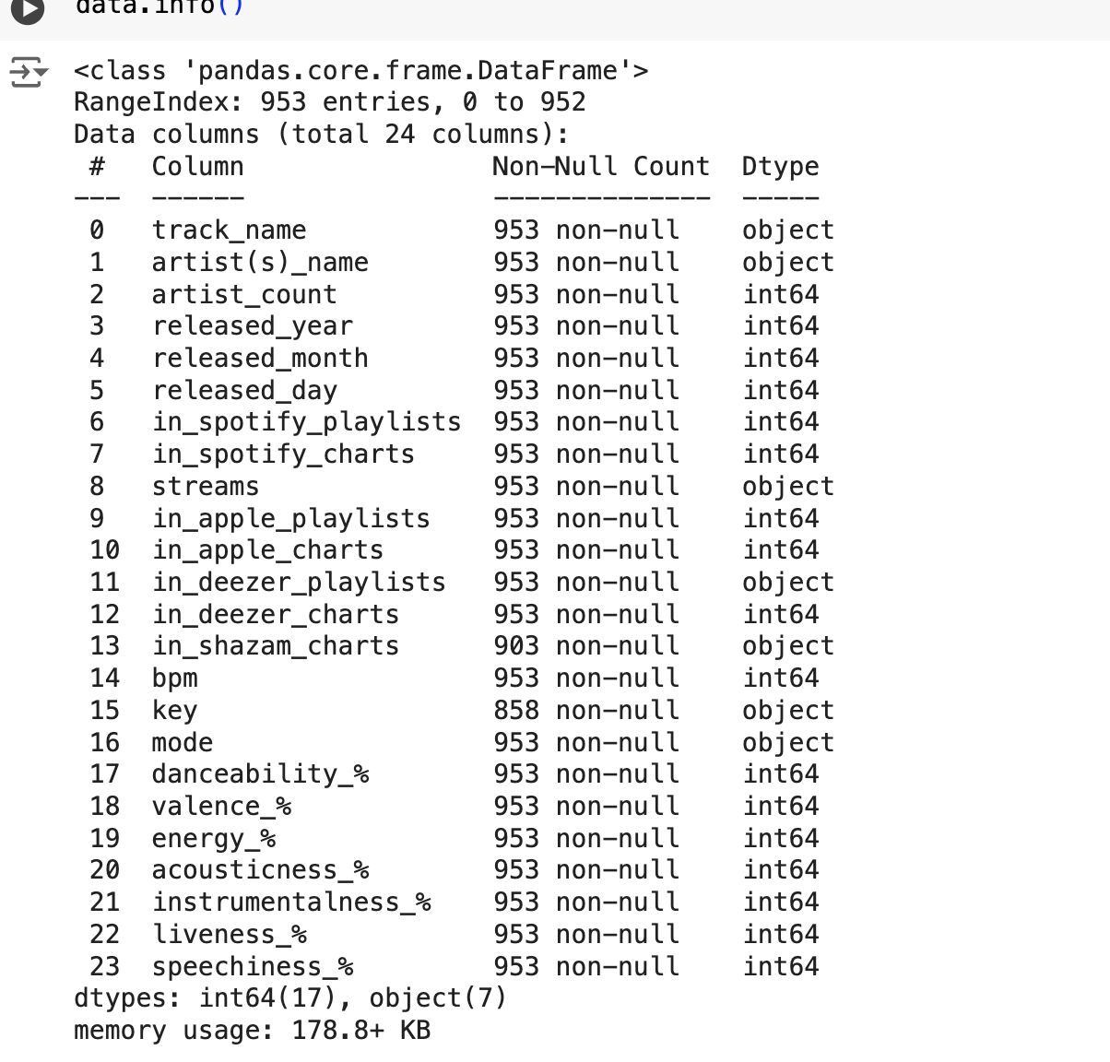

#### **3. Artist Count Distribution**

* **Most Common Artist Count (Mode)**: 1 artist

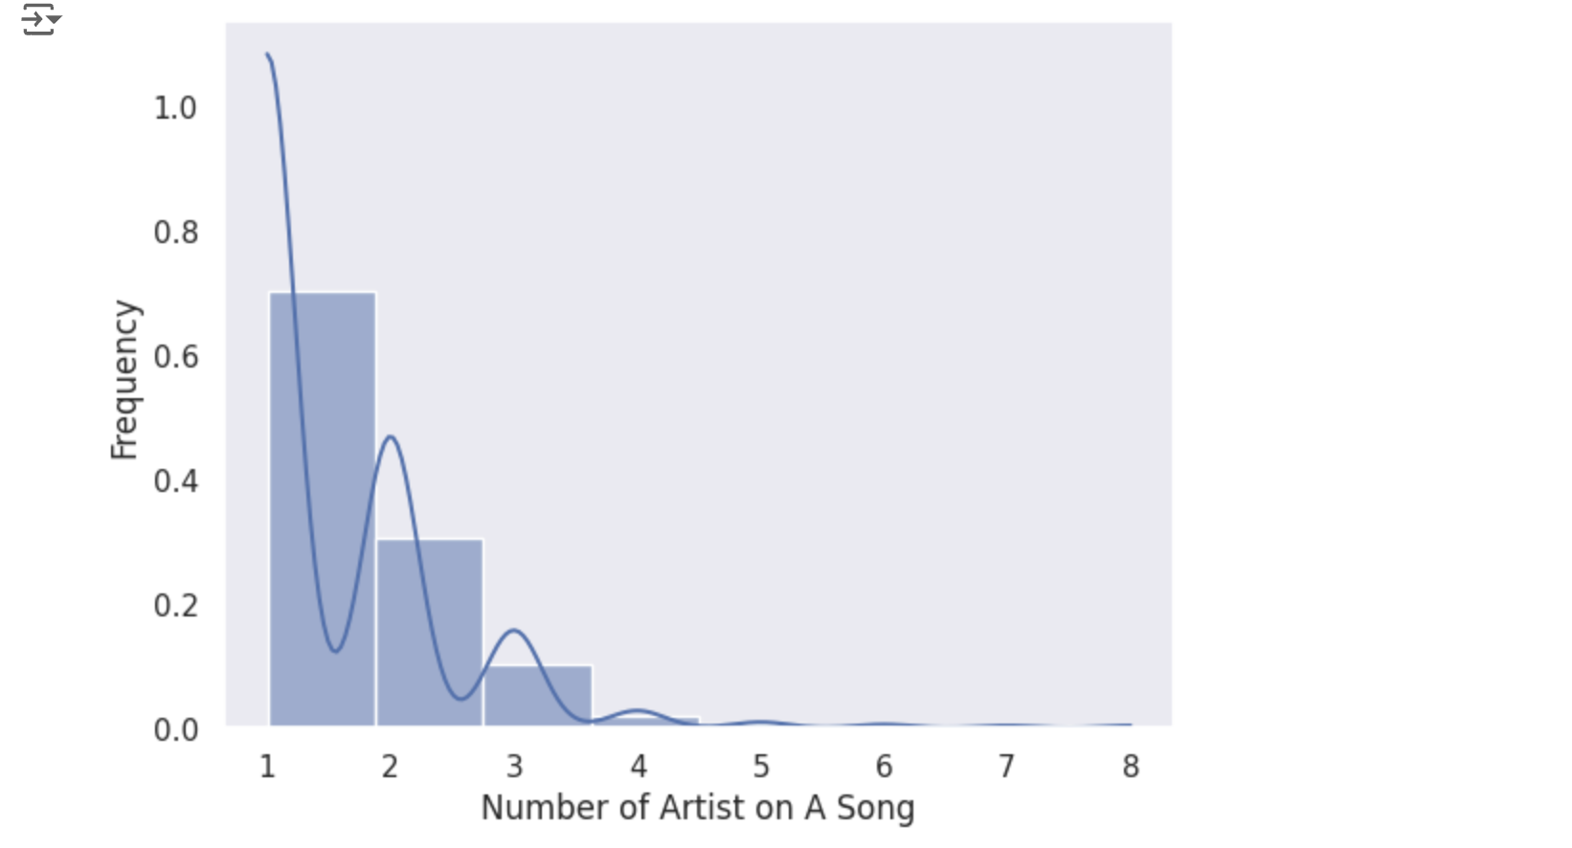

* **Poisson Distribution Fitting**

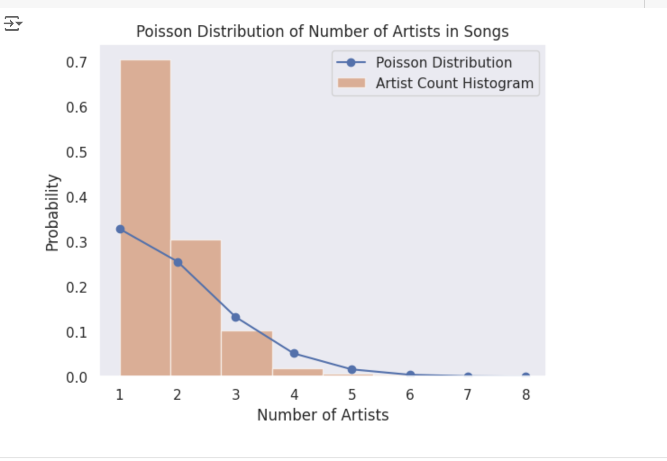

* + **Lambda (λ)**: 1.56 (mean number of artists per song)
  + **Variance**: 1.56
  + **Probability of 1 Artist**: 33%
  + **Probability of 2 Artists**: 26%
  + **Probability of 3 Artists**: 13%
* The Poisson distribution fit well for modeling the count of artists, showing that the most likely number of artists per song is 1.

#### **4. Probability Calculations**

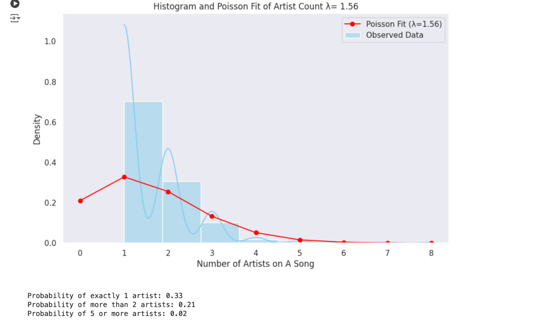

* **Probability of Exactly 1 Artist**: 0.33 (33%)
* **Probability of More Than 2 Artists**: 0.21 (21%)
* **Probability of 5 or More Artists**: 0.05 (5%)

#### 

#### 

#### **5. Hypothesis Testing and Confidence Interval**

* **Confidence Interval for Mean Artist Count (λ)**:
  + **95% Confidence Interval**: (1.48, 1.64)
  + **Z-Statistic for Hypothesis Test (λ = 2)**: -9.69
  + **P-Value**: 0.0000
  + **Conclusion**: The mean number of artists is significantly different from 2 (i.e., the mean number of artists is less than 2).

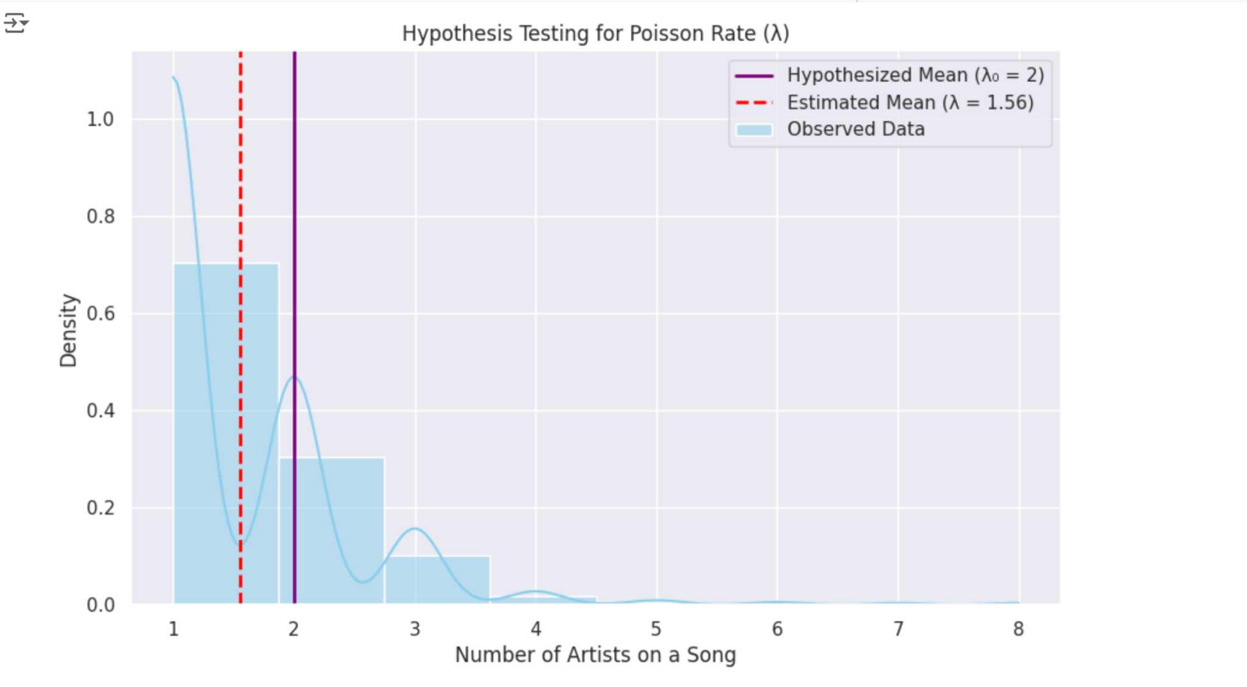

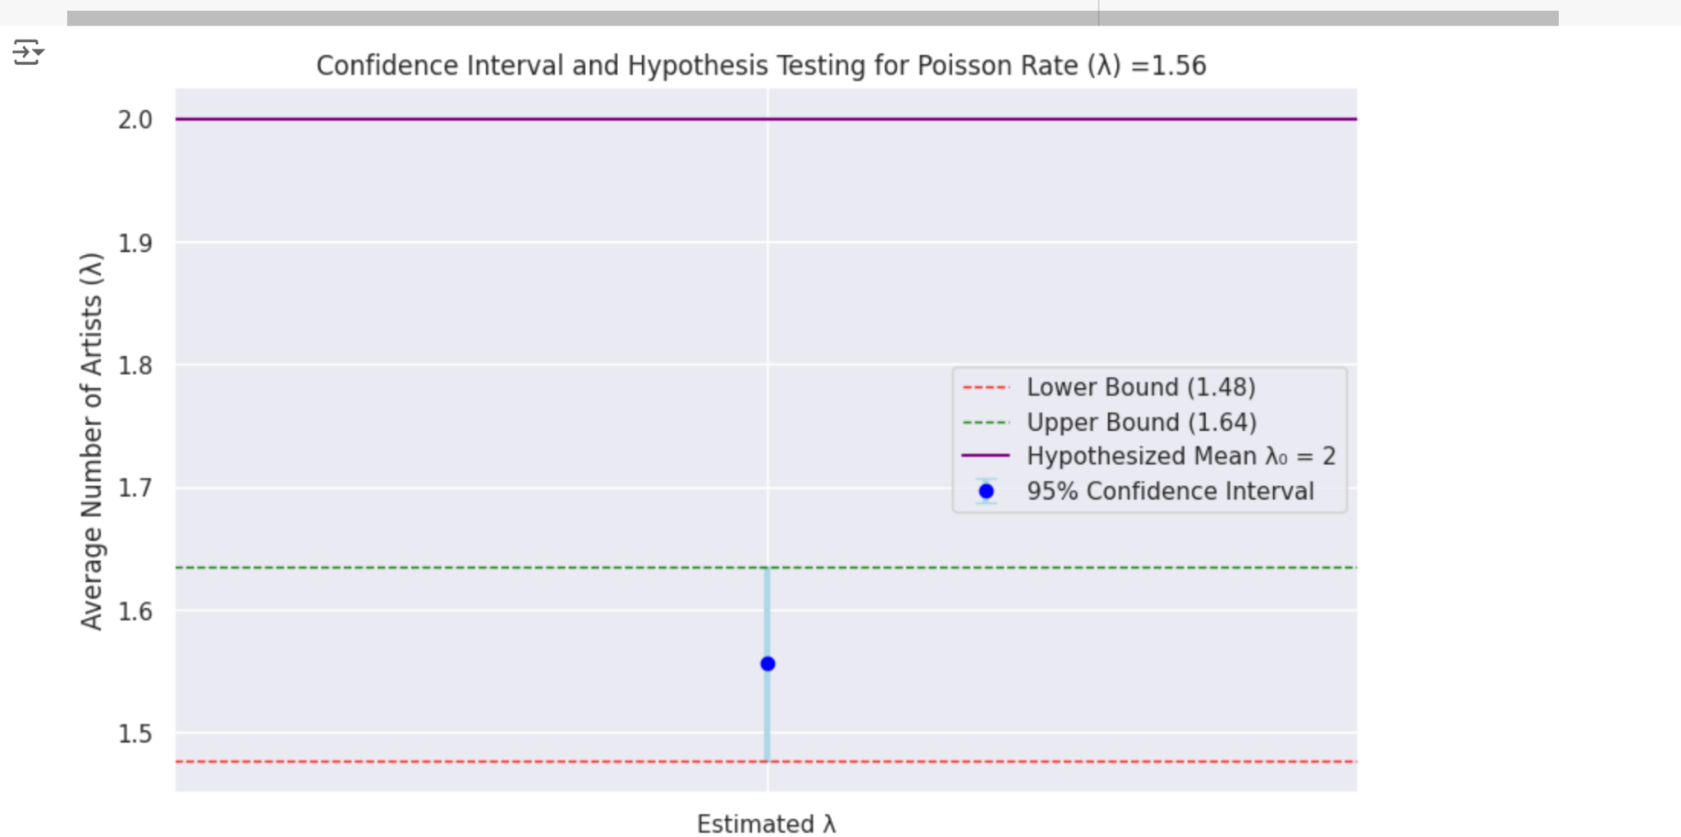

#### **6. Linear Regression Model for Stream Prediction**

* **Model Summary**:
  + **R-squared**: 0.68
  + **Adjusted R-squared**: 0.67
  + **Mean Squared Error (MSE)**: 1.15e10
  + **Significant Features**: artist_count, in_spotify_playlists, in_spotify_charts, bpm, and released_year.
* The linear regression model explained 68% of the variance in streams, but multicollinearity among the features indicated potential overfitting.

#### **7. Correlation Matrix**

* **Key Correlations**:
  + Strong correlations between streams, in_spotify_playlists, and in_apple_playlists were observed, indicating a high degree of multicollinearity.
  + The released_year had a high VIF value of 10.28, further confirming its collinearity with other variables.

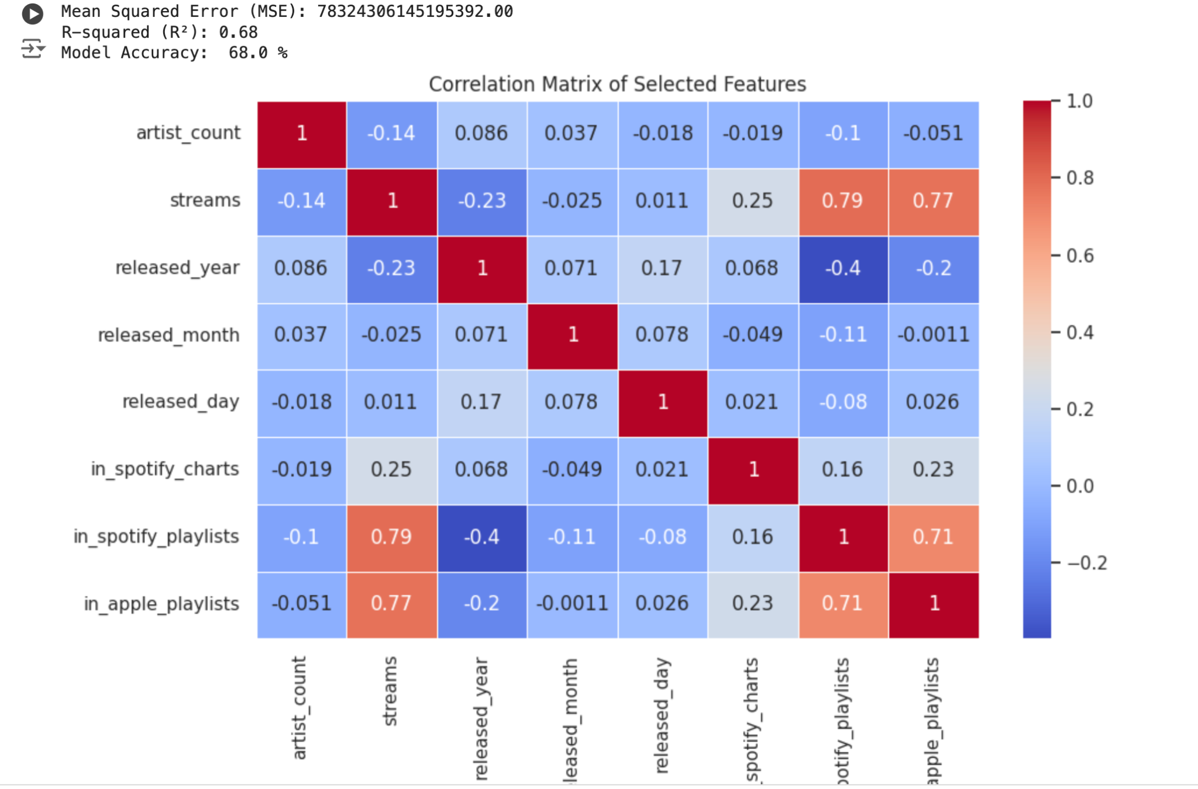

#### **8. Variance Inflation Factor (VIF)**

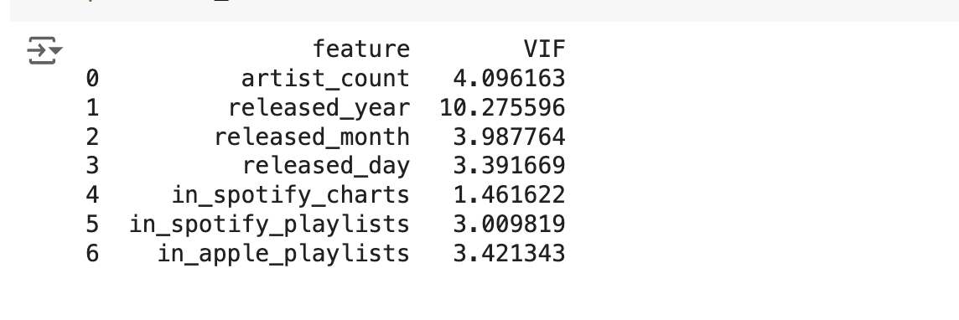

* **VIF Results**:
  + released_year: 10.28 (high multicollinearity)
  + artist_count: 4.10
  + in_spotify_playlists: 3.01
  + in_apple_playlists: 3.42
* High VIF values for several variables suggest that the linear regression model may have stability issues, which would require regularization techniques like Ridge or Lasso regression to correct.

#### 

#### **9. Chi-Square Test**

* **Chi-Square Statistic**: 7.58
* **P-value**: 0.005
* **Conclusion**: There is a significant association between the number of artists in a song and whether it was released before or after 2010.

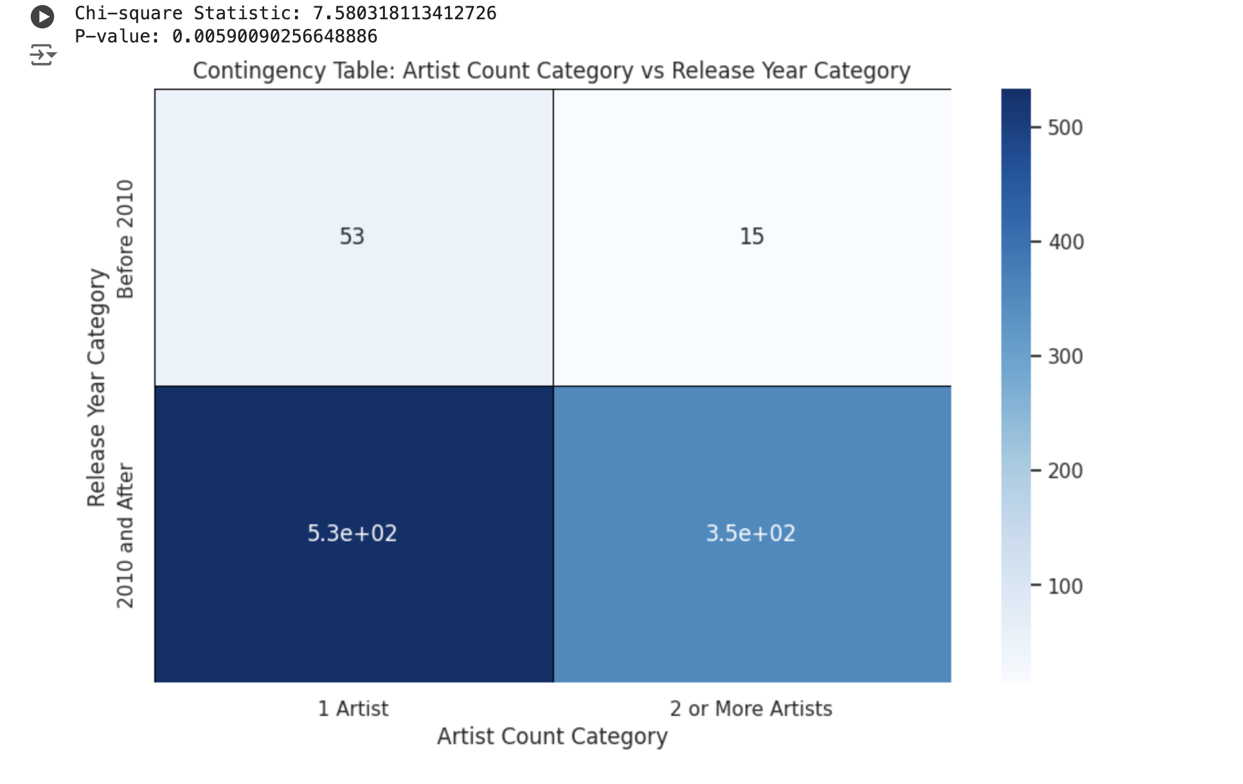

#### **10. Two-Sample T-Test**

* **T-Statistic**: -3.37
* **P-value**: 0.0012
* **Conclusion**: There is a significant difference in the number of artists collaborating on songs released before 2010 and after 2010. The result indicates an increase in collaborations in recent years.

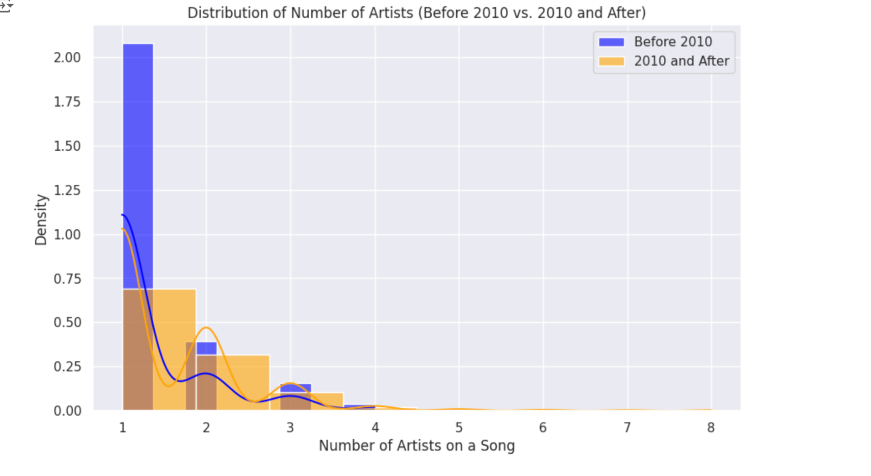

**11. Regression showing relationship between most stream songs (a) spotify (b) apple playlist**

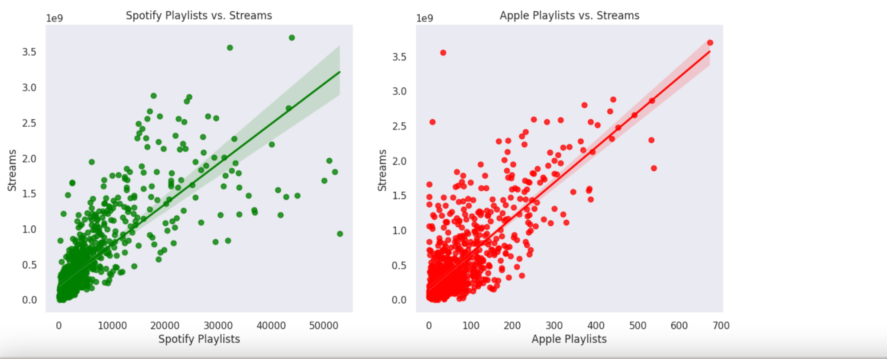

##### **12 . Linear Regression Residual Plot**

* The residual plot for the linear regression model indicated some non-linearity and heteroscedasticity, suggesting that a more complex model or transformations may be needed for better predictions.

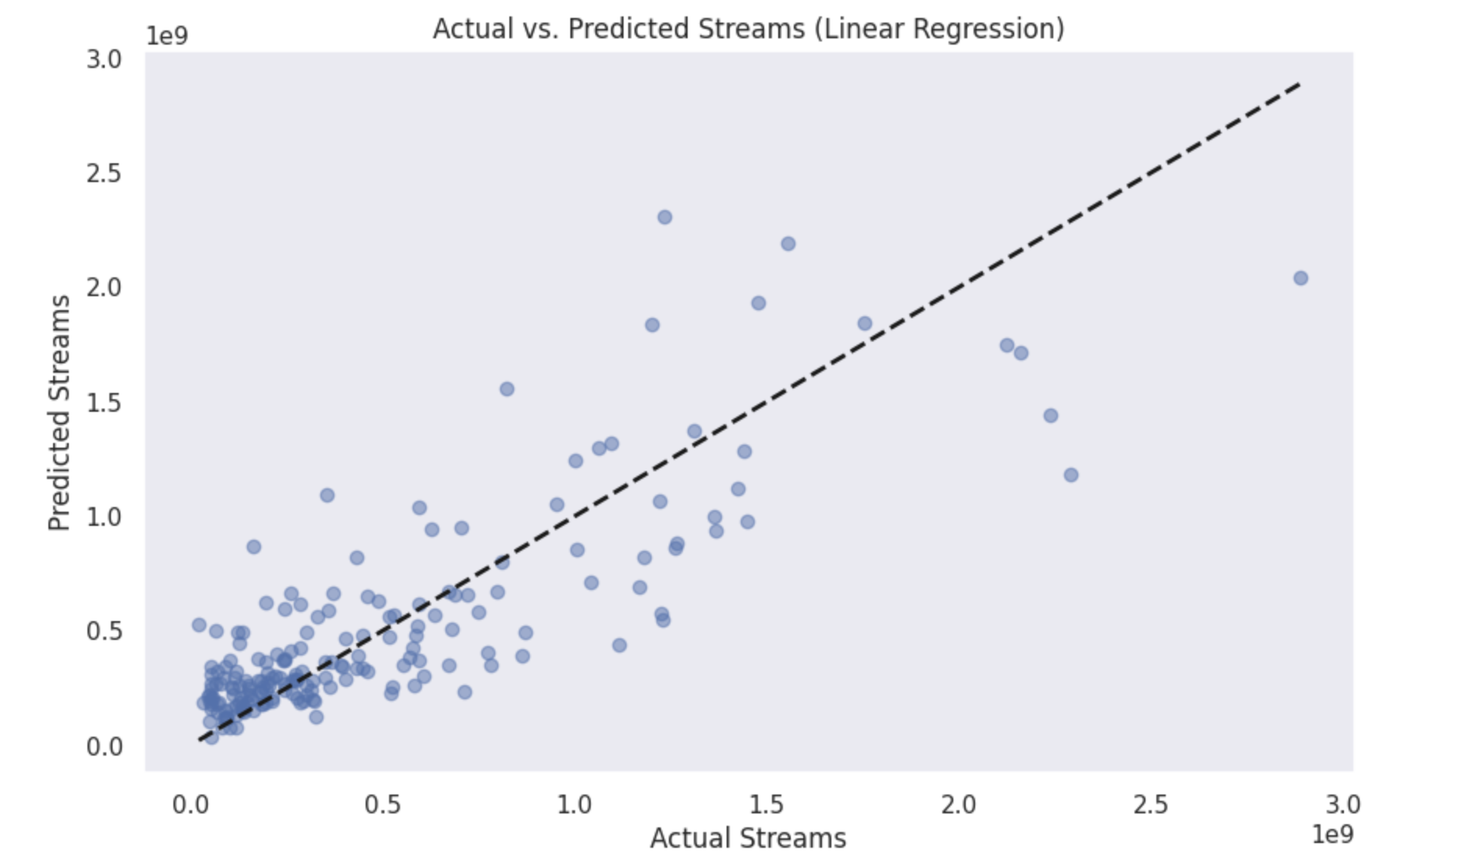

—-----------------------------The End—-----------------------------------------------------------------------